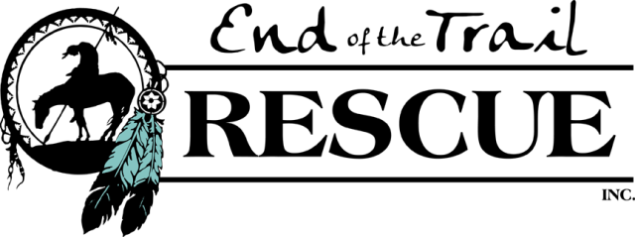

www.eottr.org

5814 Hwy 348, Olathe, CO 81425
Phone: 970.901.5020 Fax: 970.323.9090

PLEASE READ OUR OUTLINE OF ADOPTION PROCESS BEFORE SUBMITTING YOUR SURVEY
ADOPTION SURVEY

Please email completed survey to End of the Trail Rescue, Inc. (“EOTTR”) (info@EOTTR.org), or drop off at our facility (by appointment only).

We appreciate your interest in adopting a horse rescued by EOTTR. To ensure that each one of our horses finds a permanent and loving home, our survey asks several detailed questions which are a necessary first step in the process of matching you with the right horse. All information will be kept completely confidential.
Each individual horse has a specific adoption fee based on physical and mental soundness ranging from $500 to $1500+.
Adoption Fees are Non Refundable

(You may “Tab” through the fields to enter information digitally or print and then write in your information.

Name:

Date:

Street Add.:

City/St/ Zip:

Mailing Add.:

City/
St/ Zip:

Home Phone:

Work:

E
-
mail:

__________________________________

Cell
:

______________________________

Name of Horse (s) you are interested in adopting: __________________________________________________________.
Why did you choose the horse(s) named above? __________________________________________________________________
______________________________________________________________________________________________________
List the activities you plan to do with you adopted horse (companion only, show, light/hard riding) (Please note that adopters are prohibited from using the horse for purposes of professional rodeo, barrel racing, horse racing, or other similar commercial purposes.) ________________________
____________________________________________________________________________________
Is this your first horse? _________ If no, when did you own a horse? ________________________________

Were you the sole caretaker for the horse? ________ If no, who helped? ________________________________
When was the last time you rode and/or handled a horse? _______________________________________________________ Do you have an age/size/breed/gender preference?

Will you accept a horse with a limitation?
Lameness: None: Slight: Ridable w/ Special Care: Ridable w/ Significant Care:
Behavioral: None: Slight: Needs Confident Handler: Needs Retraining:

Height:

Weight:

Blindness: None: One-Eyed or Partial Blindness: Any Blindness:
Will you adopt a Companion (non-ridable) horse?
Who will be the primary handler/rider? Age:
a) Riding experience:
b) Rider Experience Level
Beginner | Rider is new around horses, comfortable riding at a walk.
Advanced Beginner | Comfortable at walk and trot, some experience with faster gaits.
Intermediate | Comfortable at all gaits, can handle horses that test rider with some bucking / spooking.
Experienced | Comfortable handling difficult horses in various environments / situations.
Very Experienced | Have previous experience training horses, or experience with handling green horses.
c) Wanted Horse Level
Beginner | Horse that is calm and gentle, beginner / child could handle
Advanced Beginner | Horse is generally calm, but not good for new rider or small child.
Intermediate | Horse occasionally tests rider and / or acts up (ie: bucking, spooking).
Experienced | Horse continually tests rider, acts up and / or has special needs.
Very Experienced | Horse is hot / very sensitive / green or untrained.
d) For untrained horses - Training costs can exceed $400/month, are you planning to hire a trainer if you adopt a horse above your experience level? If yes, who:_______________________________________ Phone:__________________
What type of riding and activities do you plan to do with your adoptive horse? (check all that apply)
English: Western: Pleasure/trail: Westernaires: Showing: Dressage:
4-H: Roping/barrels: Hunter/Jumper: Other:

Where will the horse be kept? Home: __ Boarding Stable: __ Other:
A) Horse will be provided: Barn Sheltered stall Pasture:

Do you own or lease your property? (Please Circle One) Own: __ Lease: __
Do you feel confident that you are able to financially provide for this horse the proper veterinary, farrier, emergency care, etc. for the rest of his/her life? (Horse ownership can exceed $300.00-$500.00 per month). ______________________________________________________.

In the event this horse needs extensive medical care, are you willing to do whatever it takes to provide the best quality of life for him/her? _______________________________________________________________________.

Horses are social herd animals and no horse may be kept without a companion. Do you currently have a companion animal for this horse (another horse, a donkey, a goat etc.)?
Yes: __ No: ____ Explain: ________________________________________

How did you hear about EOTTR? ________________________________
*Adoption survey will be kept on file for 1 year from date it is submitted to EOTTR.

By signing this Survey, you certify that you are over the age of 21 and all information contained in this Survey is truthful to the best of your knowledge.

_______________________________________________________________________
Signature Date

